About this manual
This manual is designed to assist you in setting up and using the OneTouch Touchscreen. Information in this document has been carefully checked for accuracy; however, no guarantee is given to the correctness of the contents. The information in this document is subject to change without notice.

Edition
1st Edition, August, 1998

Copyright
© Copyright 1998, All Rights Reserved
This document contains proprietary information protected by copyright. All rights are reserved. No part of this manual may be reproduced by any mechanical, electronic or other means, in any form, without prior written permission of Ingenious Technology Co., Ltd.
OneTouch is a registered trademark of Ingenious Technology Co., Ltd.
Regulating Approvals: FCC/CISPR 22/CLASS B, CE

Trademarks
All trademarks and registered trademarks are the property of their respective owners.
Federal Communications Commission Statement
This equipment has been tested and found to comply with the limits for a Class B digital device, pursuant to Part 15 of the FCC Rules. These limits are designed to provide reasonable protection against harmful interference when the equipment is operated in a residential environment. The equipment generates, uses, and can radiate radio frequency energy and if not installed and used in accordance with the instructions, may cause harmful interference to radio communications. However, there is no guarantee that interference will not occur in a particular installation. If this equipment does cause harmful interference to radio and television reception, which can be determined by turning the equipment off and on, the user is encouraged to try to correct the interference by one or more of the following measures:
- Reorient or relocate the receiving antenna.
- Increase the separation between the equipment and the receiver.
- Connect the equipment into an outlet on a circuit different from that to which the receiver is connected.
- Consult the dealer or an experienced radio/TV technician for help.

Shielded interconnect cables and a shielded AC power cable must be employed with this equipment to insure compliance with the pertinent RF emission limits governing the device. Changes or modifications not expressly approved by the system manufacturer could void the user authority to operate the equipment.

Table of Contents
Table of Contents
Table of Figures
Chapter 1
Getting Started
Introducing The OneTouch Touchscreen
Unpacking the OneTouch Touchscreen
Precautions
Chapter 2
Installing the Hardware
Hardware Installation for the Internal Touchscreen
Hardware Installation for the External Touchscreen
Hardware Installation for the TouchNote
Chapter 3
Installing the Software
Software Installation For Windows 98 & Windows 95
Software Installation For DOS and Windows 3.1
Chapter 4 30
Operating the OneTouch Touchscreen 30
Basic Touchscreen Operation 30
Program Introduction 32
Driver program description 32
Positioning Program Description 33
Test Program Description 36
Program Disk Files 41
Chapter 5 42
Troubleshooting and Maintenance 42
Maintenance 42
General Troubleshooting 42

Table of Figures
Figure 2-1: Attaching the Edge Strips Error! Bookmark not defined.
Figure 2-2: Exploded Diagram of the Internal Installation Error! Bookmark not defined.
Figure 2-3: Connecting the Controller Box (17" and larger) Error! Bookmark not defined.
Figure 2-4: Connecting the Controller Box (15" and smaller) Error! Bookmark not defined.
Figure 2-5: Preparing the Monitor Error! Bookmark not defined.
Figure 2-6: Adjusting the Touchscreen Error! Bookmark not defined.
Figure 2-7: Preparing the Touchscreen Error! Bookmark not defined.
Figure 2-8: Attaching the Touchscreen to the Monitor Error! Bookmark not defined.
Figure 2-9: Connecting the Touchscreen (15" and smaller) Error! Bookmark not defined.
Figure 2-10: Connecting the Touchscreen (17" and larger) Error! Bookmark not defined.
Figure 2-11: Attaching the TouchNote Error! Bookmark not defined.
Figure 2-12: TouchNote Attached to Notebook Error! Bookmark not defined.
Figure 3-1: OneTouch Setup Utility Dialog Box Error! Bookmark not defined.
Figure 3-2: Driver Utility Dialog Box Error! Bookmark not defined.
Figure 3-3: Driver Utility Dialog Box Error! Bookmark not defined.
Figure 3-4: Driver Utility Dialog Box Error! Bookmark not defined.
Figure 3-5: OneTouch Make Point for Windows Display Error! Bookmark not defined.
Figure 3-6: Fixed Position Display Error! Bookmark not defined.
Figure 3-7: Reboot Message Dialog Box Error! Bookmark not defined.
Figure 3-8: Driver Utility Dialog Box Error! Bookmark not defined.
Figure 3-9: Installation Display for DOS Error! Bookmark not defined.
Figure 3-10: Installation Display for DOS 24
Figure 3-11: Installation Display for DOS Error! Bookmark not defined.
Figure 3-12: Installation Display for DOS Error! Bookmark not defined.
Figure 3-13: Installation Display for DOS Error! Bookmark not defined.
Figure3 -14: Installation Display for DOS Error! Bookmark not defined.
Figure 3-15: Installation Display for DOS Error! Bookmark not defined.
Figure 3-16: Installation Display for DOS Error! Bookmark not defined.
Figure 3-17: Make Point Display for DOS 28
Figure 3-18: Fixed Position Display for DOS 28
Figure 4-1: Screen Alignment Display 34
Figure 4-2: Test Screen 1 36
Figure 4-3: Test Screen 2 37
Figure 4-4: INTCTEST Flowchart 37
Figure 4-5: Test Screen 3 38
Figure 4-6: Test Screen 4 39
Figure 4-7: Test Procedure Flowchart 40

Chapter 1

Getting Started

Introducing The OneTouch Touchscreen
Congratulations on your purchase of the OneTouch touchscreen! The OneTouch touchscreen’s innovative design provides you with an interface that brings you closer than ever to your computer. Ideal for POS (Point-of-Sale), training applications and games, simply touch the appropriate place on the screen to carry out your command!
Our touchscreens use an analog resistive technology that allows high light transmission to provide excellent image clarity. Unlike other touchscreen technologies, such as infrared or analog capacitive devices, resistive touchscreens can be activated by any stylus — finger, gloved hand, or dull pointer, with an accurate response every time.
Our OneTouch touchscreens come in five basic models; three internal, spherical and external models for CRT monitors, an external model for notebook computers and flat models for LCD Monitors. Our models are being used extensively in the following fields:
- Public Services
Banks, Libraries, Train and Bus Services and Tourist Information
- Training Schools
Flight Simulation, Children’s Education and other areas where Computer Aided Instruction (CAI) is employed
- Multimedia
Business Presentations and Advertising
- Entertainment
Video Game Arcades

Unpacking the OneTouch Touchscreen
Before you unpack your OneTouch touchscreen, prepare a stable, level and clean surface near your computer. As you unpack the OneTouch touchscreen, make sure the following items are included in the box and are in good condition.
Internal Touchscreen
- Internal touch panel
- Controller box and connecting cable
- Four edge strips + Two Front edge strips
- The accessories package (containing four rubber insulator plugs, four washers and four screws)
- Installation software
External Touchscreen
- External touch panel (with built-in controller) and connecting cable
- Installation software
Flat Touchscreen
- Flat touch panel
- Controller box and connecting cable
- Installation software
This User’s Manual is supplied with all models.
If you find that any of these items are missing or appear damaged, contact your OneTouch dealer immediately.

Precautions
Please pay attention to the following precautions when handling the OneTouch touchscreen:
- When operating the OneTouch touchscreen do not use objects with a hardness factor higher than 3H. Any damage resulting from such misuse will not be covered by the product warranty.
- When operating the OneTouch touchscreen do not apply a pressure greater than 15kg/cm² on the touch panel surface. This could cause irreparable damage to the touchscreen.
- This product has already been treated for low static electricity buildup and radiation emission. However, since children do not have fully developed eyesight, to avoid damage to their eyesight we recommend young children rest their eyes after 30 minutes of use.
- Before you install this product, you should turn off the power to your computer. After installing the OneTouch touchscreen, power on both the monitor and the computer.

Chapter 2

Installing the Hardware

Hardware Installation for the Internal Touchscreen
This procedure should only be performed by a qualified service technician. Please review the video tape of this procedure before attempting to install the touchscreen.
You will need the following items to install the touchscreen:
- The touch panel
- Four edge strips + Two Front edge strips
- The controller box
- The accessories package containing four rubber insulator plugs, four washers and four screws
- A soft foam mat (not included)
- A Philips screwdriver (not included)

Warning! | The CRT (cathode ray tube) can hold an extremely high voltage even when unplugged. Do not touch the CRT high voltage area when installing the touchscreen.
Step 1: Test the Touchscreen
Before installing the touchscreen, you should run a simple test to verify the touchscreen is working properly. The test procedure is listed below.
- Power off the computer.
- Connect the controller box to the touch panel connector.
- Connect the controller box serial connector to your computer’s serial port.
- Power on the computer.
- Insert the OneTouch utility diskette into the floppy disk drive.
- At the DOS prompt, type the following command line:
A:\>INTCTEST [Enter]
When running the above INTCTEST test ensure the active side of the touch panel is facing you (see Figure 1-1). For instructions on how to run this test, refer to the Test Program Description (see Chapter 4).

After confirming that the touch panel is working properly, you are now ready to begin the internal installation. Follow the steps that are listed below.
Step 2: Test the monitor.
Before you begin the installation procedure, test your monitor to make sure everything is working properly
Step 3: Prepare a workspace.
You will need a clean, flat stable surface to work on. Place an electrostatic proof soft foam mat or a sheet of bubble wrap on the table or counter top to protect the monitor screen glass from being scratched or damaged.
Step 4: Place the monitor on the mat.
Turn off all power to the monitor and unplug it from its power source. Carefully place the monitor on the soft foam mat with the screen glass facing down.
Step 5: Remove the monitor case.
Note that different models have different case designs. Most models use retaining screws to secure the front bezel and the monitor case to the chassis. Locate the front panel retaining screws. Remove the screws and store them in a safe place for later. Now separate the monitor case from the chassis as illustrated in Figure 1-2.
Step 6: Reposition monitor with the CRT screen facing you.
Lift the monitor and set it down with the CRT screen facing you. Carefully let the CRT lean forward until it rests in place on the chassis main board.
Step 7: Remove the chassis retainer screws.
Depending on the design of your monitor, you may also have to separate the monitor chassis from the front bezel. Locate and remove the retainer screws securing the chassis to the front bezel. Remove the front bezel. Store the screws in a safe place.
The inside of the front bezel should be smooth to the touch, so as not to damage the touch panel. If necessary, sand this surface gently with fine sandpaper until smooth.
Step 8: Clean the monitor screen glass.
Use alcohol and a soft cloth to clean the surface of the monitor screen glass. Do not spray liquid cleaners directly onto the unit. Stand away from the monitor and spray the cleaning solution onto the soft cloth. Without applying excessive pressure, clean the screen with the slightly dampened cloth.
Step :9 Put the edge strips in place on the touch panel.
For this step you will need the four edge strips that were packaged with the touchscreen. Work on one edge of the touch panel and one edge strip at a time. Carefully remove the protective plastic membrane from the rear side of the touch panel.
Now remove the plastic strip covering the adhesive surface of the edge strip. While holding the edge strip with the adhesive side facing down, carefully align the edge strip with the edge of the touch panel and place the edge strip onto the inactive area of the touch panel as shown in the illustration. Press down with firm even pressure to secure the edge strip in place. Now repeat this procedure for the three remaining edge strips.
If your monitor has a Trinitron or Diamondtron CRT, you should request a thinner edge strip from the manufacturer.

Figure 2-1: Attaching the Edge Strips
Step 10: Position the touch panel on the CRT.
Insert the touch panel between the front panel (bezel) of the monitor and the CRT. Position the touch panel so that it is centered on the CRT. Carefully place the monitor on the soft foam mat with the glass screen facing down. Now insert the four insulator plugs as illustrated in Figure 2-2. The narrow end of the insulator plug goes to the front bezel.
Figure 2-2: Exploded Diagram of the Internal Installation
Step 11: Insert the washers and screws.
Insert the four washers and screws. Tighten the screws just enough to hold the touch panel in place (you should still be able to turn the insulator plugs). Do not tighten down the screws all the way.
Step 12: Adjust the touch panel.
Carefully lift the monitor and place it down so that the screen is facing you. Adjust the touch panel so that it is properly centered over the CRT. Now remove the protective plastic membrane from the front side of the touch panel.
Step 13: Tighten down the screws.
Once the touch panel is properly aligned with the CRT, tighten down the four screws. It is important to make sure that nothing is touching or putting pressure on the active area of the touch panel.
Step 14: Connect the controller box.
For a 17" monitor and larger follow the instructions below.
Refer to the following diagram to identify the parts of the controller box.
Connect the 9-pin D-type F-head serial connector to the com-puter’s serial port. Now connect the controller box connector to the touch panel connector. Connect the keyboard to the keyboard separator connector, and then connect the keyboard separator connector to the computer keyboard port. Ensure that all connections are secure before proceeding to the next step.
Figure 2-3: Connecting the Controller Box (17" and larger)
For a 15" monitor and smaller follow the instructions below.
Connect the 9-pin D-type F-head serial connector to the computer’s serial port. Now connect the controller box connector to the touch panel connector. Ensure that all connections are secure before proceeding to the next step.
Figure 2-4: Connecting the Controller Box (15" and smaller)
Step 15: Secure Touch panel controller box to monitor case.
There are many ways to carry out this step. The procedure will vary from one model to the next. The following is a generic procedure. For this step you will need the two securing straps that came bundled with the controller.
- Remove the screws of the controller box and open the case. Remove the RS-232 cable.
- Now you must locate an available opening in the monitor case and thread the controller’s RS-232 cable through the opening. If there is no opening you will have to make one.
- Use the securing straps to secure the controller box to the inside of the monitor case. Note that if the controller box cable is too long, you may have to wrap it around one of the monitor’s internal ground wires a few times to prevent the excess cable from rattling around inside the monitor.
Step 16: Replace the case and the screws.
Step 17: Run the Touch panel diagnostic program.
Plug the monitor and the computer to an AC power source and switch them on. At the DOS prompt, run the INTCTEST program found on the floppy diskette included in the touchscreen package contents.
For instructions on how to run the above test, re-fer to the Test Program Description (see Chapter 4).

Hardware Installation for the External Touchscreen
You do not have to move the computer to a separate work station to install the touchscreen. For the installation you will need the touch panel, the connecting cable and the connectors.
Step 1: Test the monitor.
Before you begin the installation procedure, test your monitor to make sure everything is working properly.
Step 2: Prepare the monitor.
Turn off all power to your monitor and PC. Clean the surface of the monitor screen glass with alcohol and a soft cloth. Do not spray liquid cleaners directly onto the unit. Stand away from the monitor and spray the cleaning solution onto the soft cloth. Without applying excessive pressure, clean the screen with the slightly dampened cloth. Clean the top surface of the monitor to ensure the touch panel adhesive pads adhere well. Refer to the following illustration.
Figure 2-5: Preparing the Monitor
Step 3: Adjust the Touchscreen.
If the front of your monitor is curved. the touchscreen may not sit well on the monitor. To check this, place the touchscreen over the monitor and push gently on the corners (one corner at a time). The touchscreen should not tilt. If the touchscreen tilts you will have to add the cushion pads (see Figure 2-7 ).
Figure 2-6: Adjusting the Touchscreen
Step 4: Prepare the Touchscreen.
Carefully remove the protective plastic membrane from the front side of the touch panel. Now remove the plastic strips covering the Velcro adhesive pads as illustrated below.
Figure 2-7: Preparing the Touchscreen
Step 5: Attach the Touchscreen to the monitor.
Hold the touchscreen at arm's length and center it over your monitor screen. When the touchscreen is correctly aligned pull downwards so the adhesive pads adhere to the monitor as demonstrated in the following illustration.
Figure 2-8: Attaching the Touchscreen to the Monitor

The Velcro adhesive pads hold the touchscreen in place. They allow you to easily remove the touchscreen for cleaning.

Step 6: Connect the Touchscreen
Refer to the following illustration when connecting the touchscreen to a 15" monitor and smaller. Connect the 9-pin D-type F-head connector to the computer serial port.
Figure 2-9: Connecting the Touchscreen (15" and smaller)
The keyboard separator connector is used only with the 17" models and larger.
Refer to the following illustration when connecting the touchscreen to a 17" monitor and larger. Connect the 9-pin D-type F-head connector to the computer serial port. Connect the keyboard separate connector to the computer keyboard connector. Now connect the keyboard connector to the keyboard separator connector.
Figure 2-10: Connecting the Touchscreen (17" and larger)

Hardware Installation for the TouchNote
For this installation you will need the touchscreen, the connecting cable and the connectors.
Step 1: Test the LCD screen.
Before you begin the installation procedure, turn the notebook on to make sure the LCD screen is working properly.
Step 2: Prepare the notebook.
Turn off the power to your notebook. Clean the LCD screen with alcohol and a soft cloth. Do not spray liquid cleaners directly onto the unit. Stand away from the LCD monitor and spray the cleaning solution onto the soft cloth. Without applying excessive pressure, clean the screen with the slightly dampened cloth.
Step 3: Attach the TouchNote to the LCD screen.
Loosen the elastic securing strap.With one hand, hold the TouchNote in place over the LCD screen. Take the securing strap and loop it over the back of the LCD screen and secure it firmly with the Velcro adjuster as illustrated below. Now remove the protective plastic membrane from the front side of the touch panel.
Figure 1-11: Attaching the TouchNote
Step 5: Center the TouchNote.
Center the TouchNote on the LCD screen (if necessary loosen the securing strap). The following illustration shows the TouchNote securely attached to the notebook LCD screen.
Figure 2-12: TouchNote Attached to Notebook
Step 6: Connect the TouchNote.
Connect the 9-pin D-type F-head connector to the Notebook serial port.
Step 7: Removing the TouchNote.
To remove the Touchnote, loosen the elastic securing strap. Carefully lift the TouchNote free of the LCD display. Tighten the securing strap and store the TouchNote in the protective shipping carton.
When closing the LCD display, the TouchNote must be removed. Never attempt to close the LCD display with the TouchNote in place.

Chapter 3

Installing the Software

Software Installation For Windows 98 & Windows 95
To install the software to operate the OneTouch touchscreen, please refer to the following instructions.
- Insert the OneTouch utility diskette into your floppy disk drive.
- Choose Run from the Start menu.

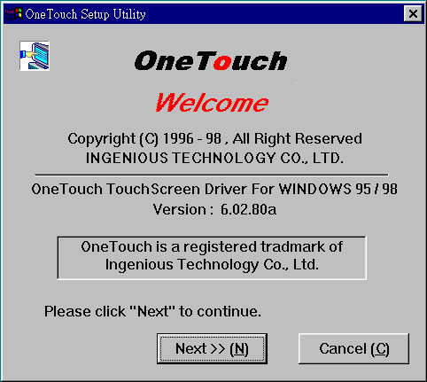
- Type a:\win98\setup (if the diskette is in drive b, type b:\win98\setup). The OneTouch Setup Utility Dialog Box should appear.

Figure 3-1: OneTouch Setup Utility Dialog Box
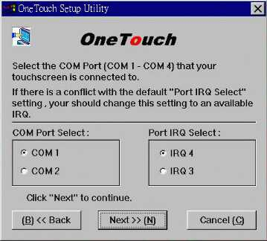
- Click the [Next] button. The OneTouch Driver Utility Dialog Box should appear.

Figure 3-2: Driver Utility Dialog Box

- Select the COM Port (COM 1 — COM 4) that your touchscreen is connected to.
- If there is a conflict with the default ”Port IRQ Select” setting, i.e., you should change this setting to an available IRQ.
- Click the [Next] button to continue next setp..
- Put a check in the box next to Select OneTouch Right Button ON/OFF to enable the right mouse button feature.
- Click the [Next] button to continue next step.

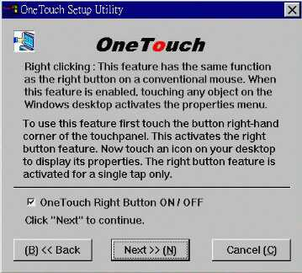
Figure 3-3: Driver Utility Dialog Box
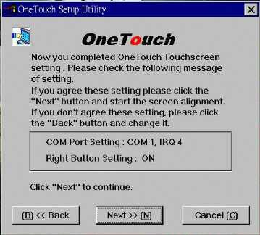
- Now you completed OneTouch touchscreen setting. Please check the following message of setting. If you agree these setting, please click the [Next] button to start the screen alignment.
Figure 3-4: Driver Utility Dialog Box
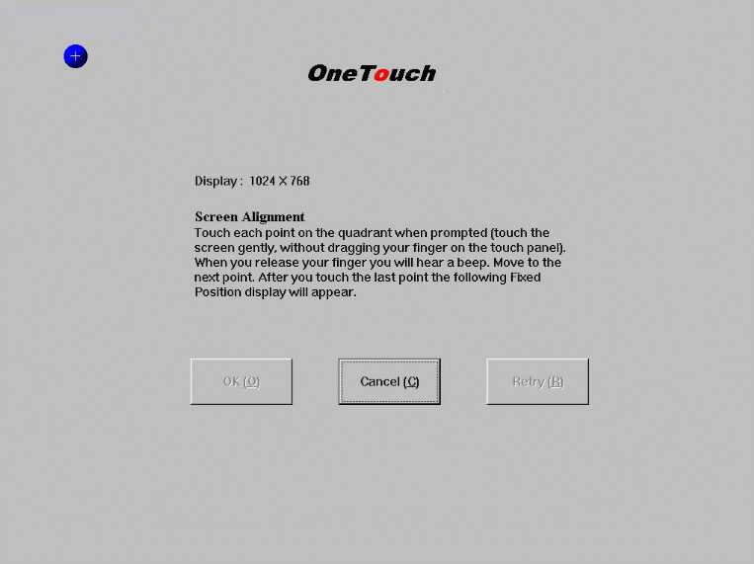
Figure 3-5: OneTouch Make Point for Windows Display
- Touch each point on the quadrant when prompted (touch the screen gently, without dragging your finger on the touch panel). When you release your finger you will hear a beep. Move to the next point. After you touch the last point the following Fixed Position display will appear.
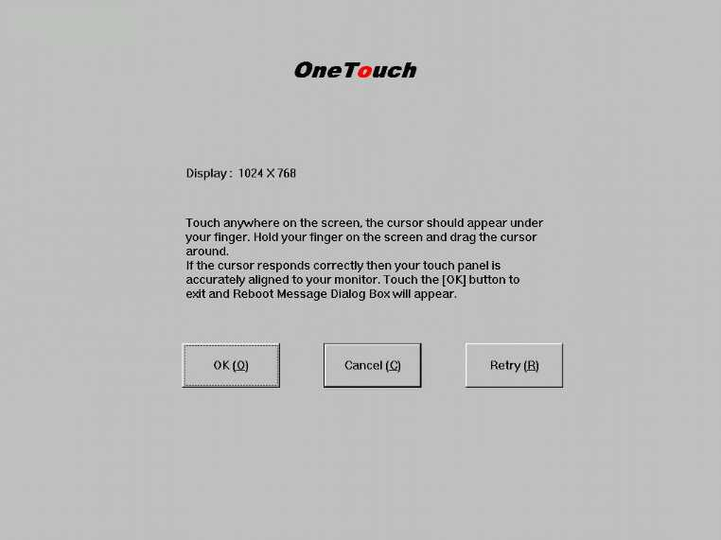
Figure 3-6: Fixed Position Display
If you are not satisfied with the screen alignment select the Retry button (this can be done from the keyboard by typing [R]) and repeat step 11.
- Touch anywhere on the screen; the cursor should appear under your finger. Hold your finger on the screen and drag the cursor around. If the cursor responds correctly then your touch panel is accurately aligned to your monitor. Touch the [OK] button to exit and the Reboot Message Dialog Box will appear.
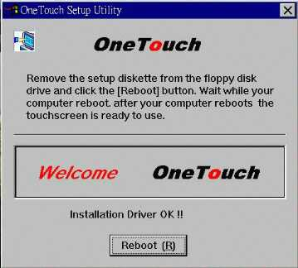
Figure 3-7: Reboot Message Dialog Box
- Remove the setup diskette from the floppy disk and click the [Reboot] button after “ Installation Driver OK” appear.

This completes the installation procedure for Windows 98 & Windows 95. The following section covers the installation for DOS and Windows 3.1.

We support three functions in OneTouch: one is Mkscreen for alignment, the other is Config for Right Button and Com Port, another is Uninstall. You can choose OneTouch from Start menu in Program after installation.
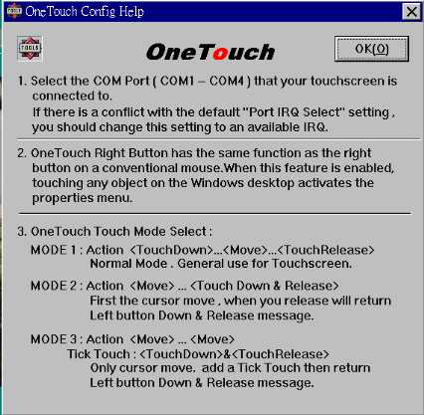
Figure 3-8: Driver Utility Dialog Box

Software Installation For DOS and Windows 3.1
Please refer to the following instructions to install the OneTouch software for DOS and Windows 3.1.
- Insert the OneTouch utility diskette into your floppy disk drive.
- At the DOS prompt C:> , type A:INSTALL (If the diskette is in drive B, type B:INSTALL) then press [Enter]. You should see the following display.
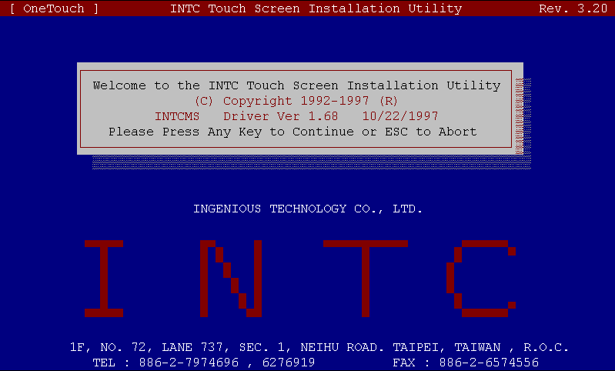
Figure 3-9: Installation Display for DOS
- To continue the installation press any key . You will see the following display on your screen.
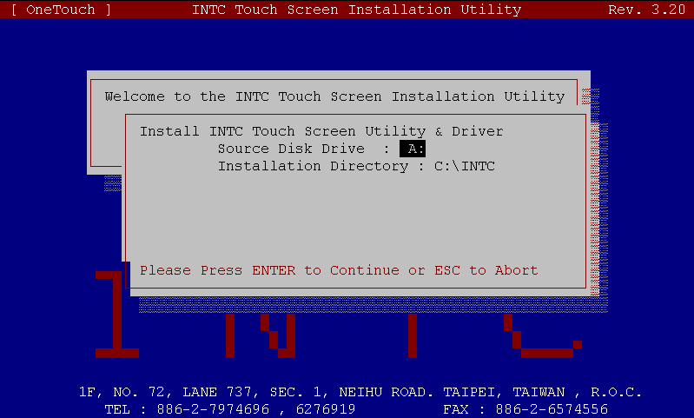
Figure 3-10: Installation Display for DOS
- At the prompt Source Disk Driver:, type the drive (A or B) that the installation diskette is in. Press [Enter]. The following screen display should appear.
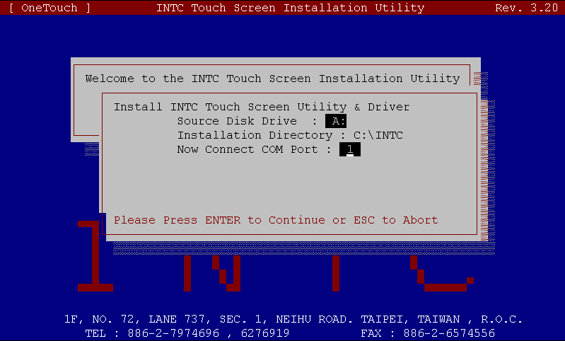
Figure 3-11: Installation Display for DOS
- At the prompt Now Connect COM Port:, type number 1,2,3 or 4 (depending on which COM Port your touchscreen is connected to) and press [Enter]. You will see the following display.
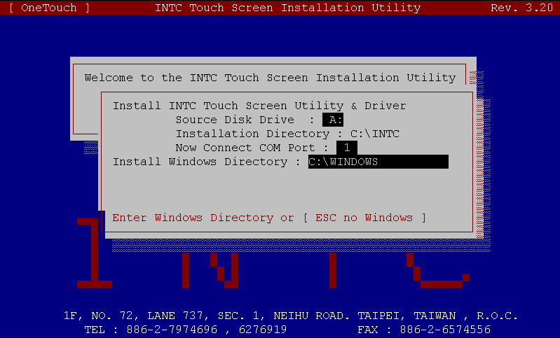
Figure 3-12: Installation Display for DOS
- At the prompt Install WINDOWS Directory:, type the directory in which Windows is installed. Press [Enter]. The following display should appear.
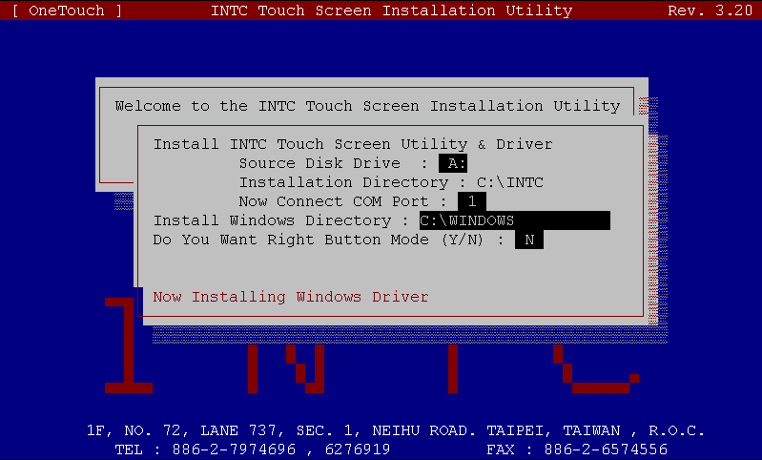
Figure 3-13: Installation Display for DOS
- At the prompt Do You Want Right Button Mode (Y/N) :, type [N] (DOS does not support right button mode). Now press [Enter]. You will see the following display.
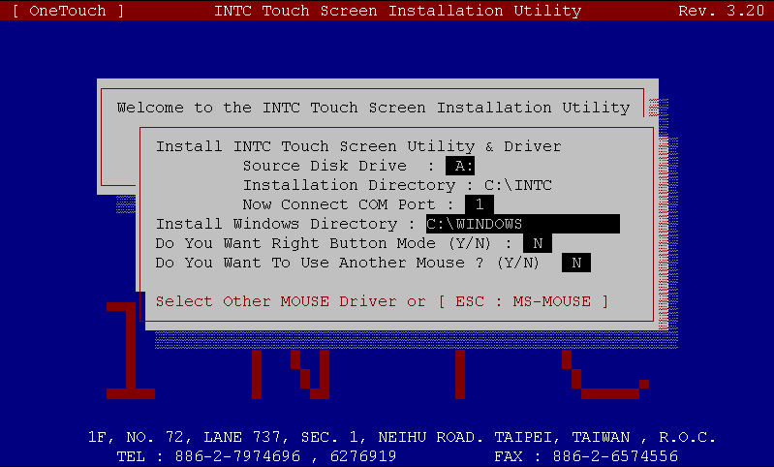
Figure3 -14: Installation Display for DOS
- At the prompt Do You Want To Use Another Mouse (Y/N) : type [N] (if your mouse is not MS compatible type [Y] and type the directory of your mouse driver). Press [Enter]. You will see the following display.
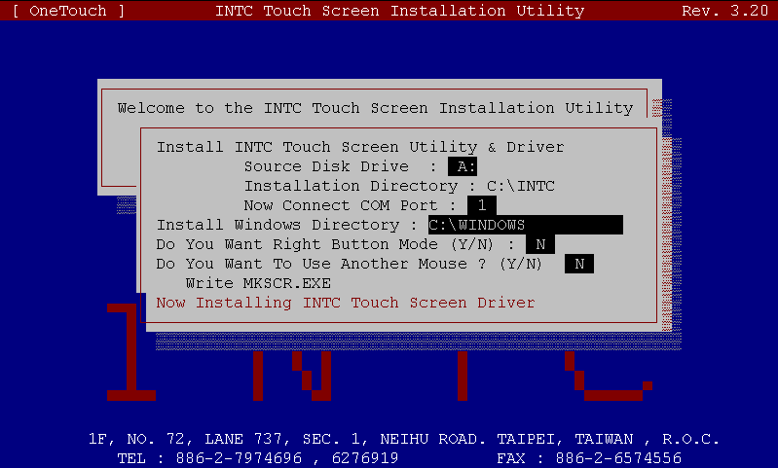
Figure 3-15: Installation Display for DOS
- You are ready to install the INTC Touch Screen Driver. Press [Enter]. The following display should appear.
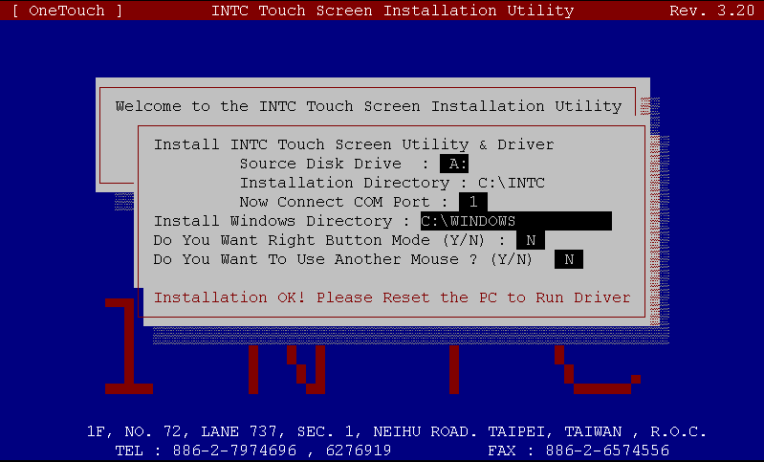
Figure 3-16: Installation Display for DOS
- The installation is complete. Remove the installation diskette from the floppy disk drive and reset your PC. When your computer restarts you will need to align the touch panel to your monitor. To start the MKSCR (screen alignment) program type the following:
C:\CD INTC
C:\INTC>MKSCR 640 480
The following display will appear on your screen.
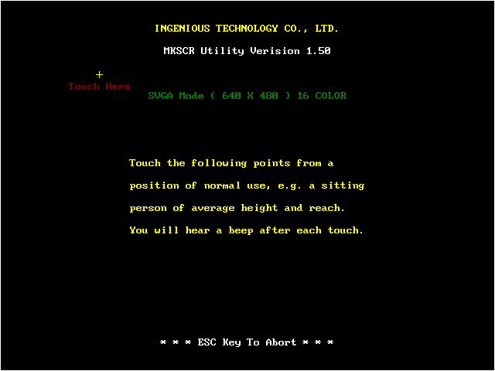
Figure 3-17: Make Point Display for DOS
- Follow the instructions on your screen. Touch each point gently without dragging your finger on the touch panel. After you touch the last point the following display will appear.
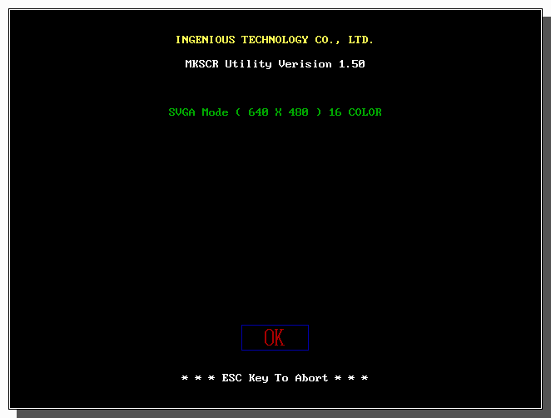
Figure 3-18: Fixed Position Display for DOS
- Touch the [OK] button on the touch panel to exit the MKSCR program (if nothing happens when you touch the [OK] button, then the touch panel is not correctly aligned to your monitor. Press the [Esc] key; this will return you to step 11. Follow the instructions on your screen). Your OneTouch touchscreen is now ready to use!
640x480 (see step 10) refers to your monitor screen resolution. If you change these settings you will have to run the position program again. You can change the COM Port or Mouse Device Driver in the AUTOEXEC.BAT file with the DOS Edit program.

Changing the COM Port or Mouse Driver
The COM Port or Mouse driver can be changed with the Edit program in AUTOEXEC.BAT.
The AUTOEXEC.BAT default settings are as follows:
CD\INTC
INCMOUSE
XMOUSE
INTCMS 1
CD\
To change the COM Port add the following:
CD\INTC
INCMOUSE
XMOUSE
INTCMS 2
CD\
To change the mouse driver add the following:
CD\INTC
C:\LOGITECH\LMOUSE
INTCMS 1
CD\

Chapter 4

Operating the OneTouch Touchscreen

Basic Touchscreen Operation
After you have installed the hardware and software for the OneTouch touchscreen, the touchscreen is ready to use. Operating the touchscreen is in many ways similar to using a conventional mouse; instead of moving the mouse around a mouse pad, you move your finger around the screen. The OneTouch touchscreen provides all the features of a two-button mouse. The basic operation of the touchscreen is described below.
- Opening menus To open a menu, such as the Start menu on the Windows desktop, touch the Start button once, lightly and rapidly. Other menus (e.g., the Format or Tools menu in Microsoft Word) are opened in the same way.
- Single tapping This technique is used to select an object or item from a menu, or to open a menu, as described above. This action is commonly referred to as licking on an object.” For most applications, single-tapping is equivalent to single clicking the left mouse button.
- Double tapping This is a common technique for launching programs from icons. To launch a program, rapidly touch the object two times. This action is commonly referred to as ouble-clicking on an object.”
- Dragging This technique is used to move items, i.e., icons, folders, text or drawings. Touch and keep your finger on the item, then move or drag the item and release it where desired. To move text: run your finger over the text to first select it. Now touch and drag the text to the new location and release.

- Right clicking This feature has the same function as the right button on a conventional mouse. When this feature is enabled, touching any object on the Windows desktop activates the properties menu. To use this feature first touch the bottom left-hand corner of the touchpanel. This activates the right button feature. Now touch an icon on your desktop to display its properties. The right button feature is activated for a single tap only. To right click another object you must touch the bottom left-hand corner of the touchpanel again.

To use the ight button” feature described above you can select it when installing the software. To enable this feature after installing the software ouble click” the OneTouch CONFIG icon in the OneTouch folder window. Put a check in the box next to neTouch Right Button ON/OFF”. Click the etup” button. The System Reboot Message box will appear. Click the K” button to reboot your system. The ight button” feature is now enabled.

Program Introduction
The OneTouch utility diskette includes the Installation program, Drive program, Position program and the Test program.
This chapter describes the function modes of the touchscreen and its software.

Driver program description
The OneTouch touchscreen device driver procedure is divided into 3 steps.
Step 1 Execute INCMOUSE.COM
This executable file is the MS-Mouse compatible device driver.
The syntax for this command is:
INCMOUSE [ENTER]
Step 2 Execute XMOUSE.COM
This executable file is the INT33H function program
The syntax for this command is:
XMOUSE [ENTER]
Step 3 Execute INTCMS.EXE
This is the Touchscreen device driver program
The syntax for this command is:
INTCMS Port [ENTER]
Parameter Description Port: Touchscreen connected with the RS-232 Port
1=COM1, 2=COM2…
Examples: INTCMS 1 Connect on COM1

Positioning Program Description
MKSCR.EXE is an executable program for the screen position and position test (This file is used to adjust the screen position and to run a screen placement test for proper alignment for DOS).
Command syntax for the screen position:
MKSCR_MaxX_MaxY [ENTER]
Command syntax for the position test:
MKSCR_D_MaxX_MaxY [ENTER]

Parameter Definitions
Depending on different display resolutions, the touchscreen supports the following modes:
Graphic Mode | MaxX | MaxY
 | 320 | 200
 | 640 | 200
 | 640 | 350
 | 640 | 400
 | 640 | 480
 | 800 | 600
 | 1024 | 768
 | 1280 | 960
 | 1280 | 1024
Test Mode | Xn (row) | Yn (column)
 | 80 | 25
 | 40 | 25
Screen Position Description
For example:
MKSCR 640 480[Enter]
Sets the 640 x 480 Graphic Mode screen position.
For example:
MKSCR 80 25[Enter]
Sets the 80 x 25 TEST Mode screen position.
The above command line syntax is for screen positioning. The value of the MaxX and MaxY parameters for each display combination depends on the video mode you are using. Please enter the correct video mode parameters. After running this command line, the following screen appears.
Figure 4-1: Screen Alignment Display
This screen allows you to set the screen position. Notice that the sequence of the “+” signs runs clockwise starting in the upper left quadrant of the display screen. To check the alignment of the touchscreen, touch each “+” sign in sequence. Each time you lift your finger from the screen, the system will emit a beep sound. After touching all four points, a cursor will appear, allowing you to check the accuracy of the screen alignment. If the screen positioning is still inaccurate, please run this procedure once more.
Positioning Test Description
Example:
MKSCR D 1024 768[Enter]
Tests the 1024 x 768 Graphic Mode screen positioning
Example:
MKSCR D 80 25[Enter]
Tests mode for mouse cursor

The above command line syntax is used to test the accuracy of the MOUSE cursor position. After running this command line, the MOUSE cursor will appear. Touch anywhere on the screen; the cursor should move to your finger. Hold your finger on the screen and drag the cursor around. If the cursor responds correctly, then your touch panel is accurately aligned to your monitor. If not, you must set the screen position again.

After setting the screen position do not adjust the monitor display settings again. If you do, you must reset the screen position.

Test Program Description
INTCTEST.EXE is the touchscreen test program. Please use this program for running a diagnostic test and for simple maintenance.
Command syntax for the test program (this must be run under DOS):
INTCTEST [Enter]
- For 15-inch monitors and smaller, the following information will appear after running the above command line. A blue screen will appear. When you touch the center of this screen, a white dot will appear. As you trace your finger across the screen, a white line will appear corresponding to the path you traced. This indicates your touchscreen is working properly.
Figure 4-2: Test Screen 1
If you touch only a single point on the screen, and a white line appears as in the following illustration, touch another point on the screen. Do this several times. Record the position and direction of these lines and contact your OneTouch dealer for assistance.
Figure 4-3: Test Screen 2
The following flow chart illustrates the test procedure for the OneTouch touchscreen.
Figure 4-4: INTCTEST Flowchart
- For 17-inch monitors and larger, one or more of the following messages will appear after running the above command line.
Find INTCMS Interface Card on COM1 (2, 3 or 4)
Baud Rate: 9600
Press any key to continue . . .
This message indicates the interface card, the touch panel, and the connecting cable are all working properly. After pressing [Enter] a blue screen will appear. When you touch the center of this screen, a white dot will appear. As you trace your finger across the screen, a white line will appear corresponding to the path you traced. This indicates your touch screen is working properly.
Figure 4-5: Test Screen 3
If you touch only a single point on the screen, and a white line appears as in the following illustration, touch another point on the screen. Do this several times. Record the position and direction of these lines and contact your OneTouch dealer for assistance.
Figure 4-6: Test Screen 4
Can Find INTCMS Interface Card, Please Check . . . .
Please Check RS-232 & K/B Connector.
This message indicates the RS-232 and the keyboard connector are not properly connected. Please check these connectors and ensure they are properly connected. Now run the INTCTEST program again. If this messages appears again, contact your OneTouch dealer for assistance.
Can Find Touch Panel, Please Check . . . .
Please Check Panel Connector.
This message indicates the RS-232 and the Keyboard connector are not properly connected
This message indicates the touch panel connector is not properly connected. Please check this connector and ensure it is properly connected. Now run the INTCTEST program again. If this message appears again, contact your OneTouch dealer for assistance.
After solving any problems that crop up, please run the INTCTEST program again. Test the touchscreen once more to verify everything is working properly.
The following flow chart illustrates the touchscreen test procedure.
Figure 4-7: Test Procedure Flowchart
If the above test procedure fails, it is possible one of the screws holding the touch panel in place is too tight. Loosen the bottom-left screw one and a half turns. Run the test again.

Program Disk Files

The function program disk includes the following files :

\WIN98\SETUP.EXE | Windows Setup Program
WIN98\CONFIG.EXE | Windows OneTouch Configuration Program
\WIN98\MKSCREEN.EXE  \WIN98\UNINSTAL.EXE | Screen Positioning Program for Windows, Win95 & Win98  Windows Uninstall Program
\DOS\INSTALL.EXE | Installation Program
\DOS\INTCMS.EXE | Touch Screen Drive Program
\DOS\INCMOUSE.COM | MS-Mouse Compatible Driver
\DOS\XMOUSE.COM | INT33H Function Driver
\DOS\MKSCR.EXE | Screen Positioning Program and Test Program for DOS
\DOS\INTCTEST | Test Program
\DOS\RTOUCH.DAT | The Screen Positioning and Screen Display Mode Data File
\DOS\KBTOUCH.DAT | Configuration File
\DOS\DEMO\MOUSE.C | Mouse Driver Function Call File
\DOS\DEMO\MOUSE.H | Mouse Driver Function Call Including File
\DOS\DEMO\TOUCH.PRJ
\DOS\DEMO\TOUCH.EXE | Demo Program
\DOS\DEMO\TOUCHDM.C | Demo Program Source File
\DOS\LIB\DEMO_LIB.C | Touch Library Demo Source
\DOS\LIB\DEMO_LIB.EXE | Touch Library Demo
\DOS\LIB\DEMO_LIB.PRJ
\DOS\LIB\\LIB.DOC | Touch Library User’s Manual
\DOS\LIB\\LIB.C | Touch Library Source

Chapter 5

Troubleshooting and Maintenance

Maintenance
To ensure your OneTouch touchscreen delivers optimal performance, the touch panel should be kept clean and in good condition. Never use a hard or sharp object, such as a knife, to activate the touch panel.
Cleaning the touch panel
Clean the touch panel regularly. Use a neutral cleaner (water or alcohol) on a soft clean cloth. Do not spray liquid cleaners directly onto the unit. Stand away from the unit and spray the cleaning solution onto the soft cloth. Without applying excessive pressure, clean the touch panel with the slightly dampened cloth.

General Troubleshooting
Before you start Troubleshooting, always check the following:
- Make sure your computer and monitor are working correctly.
- Check that the touchscreen connectors are all inserted correctly.
- Is the touch panel dirty? Now is a good time to clean it!

Problems you may run into!
You touch the touch panel but the cursor appears in a different place!

Possible solutions:
The touch panel is not correctly aligned to your monitor.
- From DOS re-run the MKSCR.EXE (from Windows re-run the WMKSCR.EXE) program. Realign the touch panel to your monitor. Run the application file. If the problem persists go to B.
- You may have stored the source files in different directories or folders when you ran the INTCMS and RTOUCH (display mode parameter). Another possibility is that there may be a conflict between the application mode and MKSCR display modes.

If you have access to functioning models of the touchscreen and the controller box try the following! Remove the touchscreen and replace it with the functioning model. Re-run the MKSCR.EXE program. If the problem is solved then your original touchscreen is broken. Contact your OneTouch dealer for help. If the problem persists, replace the controller box with a functioning model. Re-run the MKSCR.EXE program. If the problem is solved then your original controller box is broken. Contact your OneTouch dealer for help.

