KEYTEC, INC. Home of the Magic Touch
www.magictouch.com Richardson, Texas, USA

KTMT-1214 Installation Procedures:
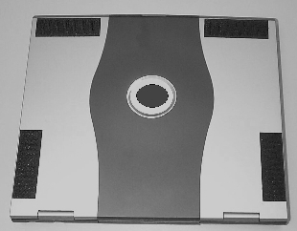
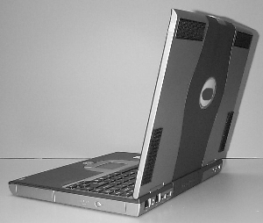
- Adhere the 4 Velcro strips to the cover of the computer as shown. Then open the cover.

- Mount the touch screen to the notebook as shown:
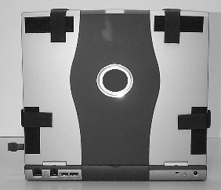
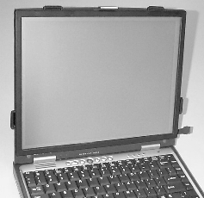

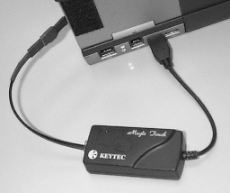
- Connect the controller to the computer (USB or serial port depending on the model of the Magic Touch). Connect the black cable between touch screen and the controller box. Make sure the pin alignment marks matche. Otherwise, the touch position will be reversed.

- Turn on the power of the computer. Follow the instructions in the Driver Installation Manual to install the correct driver for your operating system.
- Use the stylus provided for better accuracy.
- Remove the touch screen before closing the cover of the notebook. Store it carefully.
- Use display or lens cleaning cloth to clean the screen.

Revision: N070901

